FAQ Page

Definition
# Source: AI Source: Provided by: [Data Path: Persons Table -> ID Column: 1, Name_En Column: Motasem Essam] -> From: [Chatgpt (GPT‑5 Mini)] on [2/12/2026]
An FAQ Page (Frequently Asked Questions page) is a web page that lists common questions and their answers to help visitors quickly find information.

Simple Definition
# Source: AI Source: Provided by: [Data Path: Persons Table -> ID Column: 1, Name_En Column: Motasem Essam] -> From: [Chatgpt (GPT‑5 Mini)] on [2/12/2026]
FAQ Page = a page that answers the most common questions users usually ask.

What an FAQ Page Usually Includes
# Source: AI Source: Provided by: [Data Path: Persons Table -> ID Column: 1, Name_En Column: Motasem Essam] -> From: [Chatgpt (GPT‑5 Mini)] on [2/12/2026]
- List of common questions – about products, services, policies, etc.
- Clear answers – simple explanations for each question
- Categories (optional) – group questions by topic (billing, shipping, account, etc.)
- Search (optional) – find answers quickly

Purpose of an FAQ Page
# Source: AI Source: Provided by: [Data Path: Persons Table -> ID Column: 1, Name_En Column: Motasem Essam] -> From: [Chatgpt (GPT‑5 Mini)] on [2/12/2026]
- Help users get quick answers without contacting support
- Reduce repeated questions for the business
- Save time for both users and staff
- Improve user experience

Examples of FAQ Topics
# Source: AI Source: Provided by: [Data Path: Persons Table -> ID Column: 1, Name_En Column: Motasem Essam] -> From: [Chatgpt (GPT‑5 Mini)] on [2/12/2026]
- Shipping and delivery time
- Payment methods
- Refund / return policy
- Account or login problems
- Service details

Difference Between FAQ Page and Contact Page
# Source: AI Source: Provided by: [Data Path: Persons Table -> ID Column: 1, Name_En Column: Motasem Essam] -> From: [Chatgpt (GPT‑5 Mini)] on [2/12/2026]
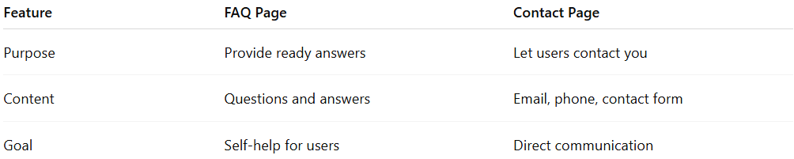
Feature | FAQ Page | Contact Page
Purpose | Provide ready answers | Let users contact you
Content | Questions and answers | Email, phone, contact form
Goal | Self-help for users | Direct communication

